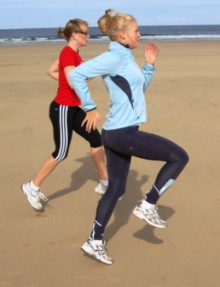

A free e-magazine for speed coaches established in 2006
Available to anyone from tonylett1@gmail.com
UKA Level 4 Development coach for Speed and Physical preparation

ISSUE 87 MAY 2014
Following the appeal to identify the author of the DVD I sent out in mid March, John Issacs came back with a name, Vern Gambetta. I should say that I get my information from a wide range of source, and where possible try them out before publishing. On this score, I have come across quite a few tests that supposedly predict the athletes potential, but I have found the end results can be well off the mark, so please, do not take them as gospel. My main subject this month is the 400metres.

2013 IAAF World Championships Women 400m final with potential shadow times for A Hewitt

!st C Ohuruogo 49.4 (12.4/11.5/12.3/13.3) 200 splits 23.8/25.6 differential 1.8 seconds
2nd A Montsho 49.4 (12.3/11.1/12.3/13.7) 200 splits 23.4/26.0 differential 2.6 seconds
A N Other 56.5! (14.5/13.5/13.5/15.0) 200 splits 28.0/28.5 differential 0.5
Alternative splits (14.0/13.5/13.5/15.5) 27.5/29.0 “ 1.5

Taking the performances of Christine Ohuruogo I have shadowed in a performance graph to see what a good club standard athlete would have to achieve for a final time of 56.5, but the graph could be used for any performance if you select a desired final time.
SHORT TO LONG SQUAD
The first competition of the season produced some positive results, which was encouraging. As I believe that variety helps to reduce boredom with younger athletes, here is one successful session we ran last week. The 400m runner needed to work on maintaining 14 second 100’s, so two athletes ran with her over the first 100m, then she jogged a 100 in 30 seconds before starting another 14 second 100m with two other athletes doing pace setting. Recovery for 3 sets was 15 mins. giving the short sprinters time to fit in staggered start runs over 110 - 95m
An abbreviation of the verbal interview with Vern Gambetta that I sent out in mid March this year.
- Race the way you train
- The race can be divided into three zones, their length being governed by the athletes physical ability
- The distribution of effort may be attributed to a 200m runner moving up, or an 800m runner moving down, and therefore the physiological state of mind and biomechanical attribute have to be taken into account. Add this to the athlete’s race experience and a coach may be able to decide on the length of the zones.
- Having discussed a race analysis with your athlete you can decide which zone you are training for in a particular session
- Two tests that may help the coach/athlete to decide speed ability. 1) the 30 second run – speaks for itself. 2) Flying 30’s, where the athlete runs 4xflying start 30m with a 30m jog recovery. The times are added together and divided by 120 to show speed in m/sec. Multiply this by 400m. (My experience shows the results using electronic timing, where off the mark, so I would suggest close scrutiny to acceleration before the timed zone, and not during it).
- Zone 1 Set up, with controlled aggression for 80-130m
- Zone 2 Hold. Mid race. Avoid calling this ‘slow’ Can be anywhere up to 200-250m
- Zone 3 Own the Finish. I like this terminology. The athlete trains to be in control over the last 80m (C Ohuruogu is a prime example)
- The winner will be the one who can hold his/her speed through the finish.
Following the advice of Vern I have divided the race into three zones, and as he says, the length of these will vary with the individual athlete, however he douse emphasize Zone 3, which can be anywhere from 250m out, but especially the final 80m where he coaches his athletes to ‘own the finish’ i.e. to control it, and we have witnessed the number of times that Ohuruogo has done just this, often coming from behind to win, without showing any signs of panic, implying that she knows exactly what she is doing.
Zone 1 is for setting the race up with controlled aggression over the first 80-130m
Zone 2 is mid race on a hold your pace which can be anything up to 200-250m, depending on your athlete, often decided by whether it is a pure 400m runner, a 200m runner stepping up or an 800m runner stepping down.
Zone 3 Own the Finish, starting from between the 250 mark to the last 80m
I shall deal with the conditioning (foundation) phase in September, so for now, lets’ just look at the:-
Competition Phase.
- Raise the intensity of training and refine it for the race, working from the finish to the start.
- Keep up strength training using some of the exercises employed in the pre competition phase A small circuit of 3-5 sets 6 reps at the beginning of the phase, reducing this to 3 reps as the season progresses. (This is obviously intended for athletes approaching, or at, national standard, so club coaches should take this, and the equipment available, into account). Exercises:- Squats, lunges, step ups, jump squats. He would also recommend, maybe as an alternative, 20 reps of bodyweight exercises. Add pull ups, upright row, pull-overs, inclined push up, standard dumbbell press, single arm row. Now I know that not everybody has the facilities the training time to do all of these, so common sense must prevail.
- During the peak of this phase he recommends 3 strength training days/week(!) for females and 2 for males
- Relays;- changing athletes position in the team can have some effect of there flat race performance
Vern very much favours Broken runs for this phase of training over Zone 3 (owning the finish). Here are some ideas:
50-70-80 = 200 50-120-80 = 250 70-150-80 = 300
60-110-80 = 250 70-100-80 = 250 30-110-80 = 220

STRETCHING
At a recent County Coaching workshop we discussed stretching, which brought up a number of variables which I list below, and would like other peoples take on this.
- Very few coaches stretch after training
- Some coaches advocated only stretching during a specific stretching day.
- I have always held a stretch for about 7 seconds, and any gains beyond this are not worthy of the time spent.
- Another coach said in order to do PNF stretching it had to be held for 20 seconds
- Some coaches quoted ‘old school thinking’ and stretched statically before training
- Others only did dynamic stretching before training ( which really means improving ROM)
- A chiropractor I visited recommends 3 x 10 seconds.
Over the next couple of months I shall be including something on stretching, starting with this

RESULTS OF STRETCHING PROJECT BY THE COPENHAGEN MUSCLE RESEARCH CENTRE 2002
OBJECTIVE: 1) To assess effect of long term stretching and stretch tolerance
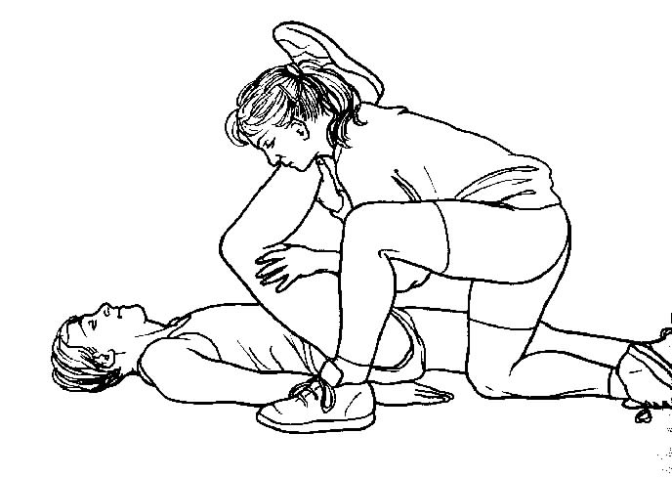
2) To assess the resistance to stretch on the hamstring group during passive knee extension while monitoring EMG reflex activity, knee joint and velocity during standard stretching
A group of 7 healthy people were tested before and after 3 weeks of training using 2 separate protocols.
- Slow stretch to a pre-determined angle with a 30 second hold between each rep before and after training.
RESULTS:
A) The torque (turning moment) rose during the stretch and declined during the hold.
B) The change in EMG was insignificant
C) There was no significant difference in stiffness, energy or peak torque about the knee joint as a result of the training
2) Similar stretch but continuous (without 30 sec hold) to the point of pain
RESULTS
- The angle to which the knee could be extended was significantly increased as a result of the training with a comparable increase in peak torque and energy. EMG showed a slight but insignificant increase

CONCLUSION
The reflex EMG of knee extension does not limit the range of movement during slow stretch and the increased range of motion due to training. Reflex EMG was due to the increased stretch tolerance rather than a change in the mechanical or viscoelastic (internal) properties of the muscle.(hamstring). In other words, the second method is more effective.

SOME THOUGHTS

We are approaching the period of optimum performance, a window of about 15 weeks which all the past training has been geared to. This is the period when you can expect the best performances from your athletes, and especially in the last 4-5 weeks of this period, It is therefore the time to consider winding down the special endurance sessions and concentrate on pure speed with long recovery spells. Eg. 6x40 from blocks x 5:00 or 6x50 x 5:00, 4-8 x 60m x 6-8:00, rolling or crouch starts of 50-60m with 15-20min recovery, 2(2x30 building speed +30 sprint).
Speed will increase with the decrease of strength and plyometrics, both of which use energy through the CNS. If you do want to put in the odd low intensity strength exercise then go for something like the bench press or power clean. As for plyometrics, if you do top up with them, make them short and fast reaction without any deep rebound squats.

